Santa’s Present Drop
Create Santa’s Present Drop using Scratch. First import some suitable pictures to use for your present and elf. The scripts you need to get your game working are:
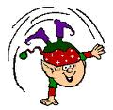
Present | Elf
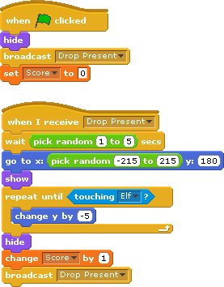 | 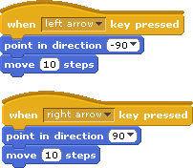

Make it better!
At the moment the game isn’t very exciting, add the following features to make it better:
- Give the user some feedback when the present hits the floor
- Duplicate your present to make more than one appear
- Give the Elf three lives that go down when a present hits the floor
- Make a Game Over screen that displays when the Elf loses all his lives
- Make a “Win” screen to display when the player completes the game (maybe a score of 50?)

